**TOPIC: HOSPITAL MANAGEMENT SYSTEM**

**GROUP (I)**

**LIST OF MEMBERS**

1. **MAHI BALARABE AHMAD UG19ICT2190**
2. **BASHIR ALIYU MUSA UG19ICT2167**
3. **AMINU MUHAMMAD NURA UG18ICT1080**
4. **IYAL TIJJANI HUSSAIN UG18ICT1032**
5. **UMAR SAEED UMAR UG18ICT1017**
6. **MUSTAPHA HASSAN ABUBAKAR UG18ICT1018**
7. **IBRAHIM IBRAHIM ABDULLAHI UG18ICT1024**
8. **SULAIMAN SABO ALIYU UG18ICT1031**
9. **HASSANA AMINU MUHD UG19ICT2158**
10. **ABUBAKAR IBRAHIM UG18ICT1112**
11. **MUHAMMAD ABUBAKAR UMAR UG18ICT1131**

**Abstract**

*Hospital Management System is an organized computerized system designed and programmed to deal with day to day operations and management of the hospital activities. The program can look after inpatients, outpatients, records, database treatments, status illness, billings in the pharmacy and labs. It also maintains hospital information such as ward id, doctors in charge and department administering. The major problem for the patient nowadays to get report after consultation , many hospital managing reports in their system but it's not available to the patient when he / she is outside. In this proposal we are going to provide the extra facility to store the report in the database and make available from anywhere in the world.*

1. **Introduction**

The project Hospital Management system includes registration of patients, storing their details into the system, and also computerized billing in the pharmacy, and labs. The software has the facility to give a unique id for every patient and stores the details of every patient and the staff automatically. It includes a search facility to know the current status of each room. User can search availability of a doctor and the details of a patient using the id. The Hospital Management System can be entered using a username and password. It is accessible either by an administrator or receptionist. Only they can add data into the database. The data can be retrieved easily. The interface is very user-friendly. The data are well protected for personal use and makes the data processing very fast. Hospital Management System is powerful, flexible, and easy to use and is designed and developed to deliver real conceivable benefits to hospitals. Hospital Management System is designed for multispeciality hospitals, to cover a wide range of hospital administration and management processes. It is an integrated end-to-end Hospital Management System that provides relevant information across the hospital to support effective decision making for patient care, hospital administration and critical financial accounting, in a seamless flow. Hospital Management System is a software product suite designed to improve the quality and management of hospital management in the areas of clinical process analysis and activity-based costing. Hospital Management System enables you to develop your organization and improve its effectiveness and quality of work. Managing the key processes efficiently is critical to the success of the hospital helps you manage your processes.

**1.3 Problem Introduction:**

**Lack of immediate retrievals:** - The information is very difficult to retrieve and to find particular information like- E.g. - To find out about the patient’s history, the user has to go through various registers. This results in convenience and wastage of time.

**Lack of immediate information storage: -** The information generated by various transactions takes time and efforts to be stored at right place.

**Lack of prompt updating: -** Various changes to information like patient details or immunization details of child are difficult to make as paper work is involved.

**Error prone manual calculation: -** Manual calculations are error prone and take a lot of time this may result in incorrect information. For example calculation of patient’s bill based on various treatments.

**Preparation of accurate and prompt reports:** - This becomes a difficult task as information is difficult to collect from various register.

**1.4 Goals**

1. User friendly
2. Simple fast
3. Low cost and effective
4. It deals with the collection of patient’s information
5. Diagnosis

**1.5 Objective:-**

1. Define hospital
2. Recording information about the Patients that come.
3. Generating bills.
4. Recording information related to diagnosis given to Patients.
5. Keeping record of the Immunization provided to children/patients.
6. Keeping information about various diseases and medicines available to cure them. These are the various jobs that need to be done in a Hospital by the operational staff and Doctors. All these works are done on papers.

**1.6 Scope of the Project:-**

* 1. Information about Patients is done by just writing the Patients name, age and gender. Whenever the Patient comes up his information is stored freshly.
  2. Bills are generated by recording price for each facility provided to Patient on a separate sheet and at last they all are summed up.
  3. Diagnosis information to patients is generally recorded on the document, which contains Patient information. It is destroyed after some time period to decrease the paper load in the office.
  4. Information about various diseases is not kept as any document. Doctors themselves do this job by remembering various medicines. All this work is done manually by the receptionist and other operational staff and lot of papers are needed to be handled and taken care of. Doctors have to remember various medicines available for diagnosis and sometimes miss better alternatives as they can’t remember them at that time.

**1.7 Modules:**

The entire project mainly consists of 7 modules, which are

* Admin module
* User module (patient)
* Doctor module
* Nurse module
* Pharmacist module
* Accountant module

**2.1 System Design:**

**2.1.1 Introduction to UML:**

UML Design the Unified Modeling Language (UML) is a standard language for specifying, visualizing, constructing, and documenting the software system and its components. It is a graphical language, which provides a vocabulary and set of semantics and rules. The UML focuses on the conceptual and physical representation of the system. It captures the decisions and understandings about systems that must be constructed. It is used to understand, design, configure, maintain, and control information about the systems. The UML is a language for:

* Visualizing
* Specifying
* Constructing
* Documenting

**2.2 UML Approach**

UML Diagram A diagram is the graphical presentation of a set of elements, most often rendered as a connected graph of vertices and arcs. You draw diagram to visualize a system from different perspective, so a diagram is a projection into a system. For all but most trivial systems, a diagram represents an elided view of the elements that make up a system. The same element may appear in all diagrams, only a few diagrams, or in no diagrams at all. In theory, a diagram may contain any combination of things and relationships. In practice, however, a small number of common combinations arise, which are consistent with the five most useful views that comprise the architecture of a software-intensive system. For this reason, the UML includes nine such diagrams:

1. Class diagram
2. Object diagram
3. Use case diagram
4. Sequence diagram
5. Collaboration diagram
6. State chart diagram
7. Activity diagram
8. Component diagram
9. Deployment diagram

Hospital Management System is used to take the data from the patients and then store it for later use. The main goal of the Hospital Management System is to accurately treat as well as decrease overtime pay.

There are various features included in the HMS. Some of the system functions include Registration, Patient check out, Report generation, and more. In this blog, let's check out the functional and non-functional requirements of the Hospital Management System in depth.

**List of the Requirements:**

1. **Adding Patients:** The Hospital Management enables the staff in the front desk to include new patients to the system.
2. **Assigning an ID to the patients:** The HMS enables the staff in the front desk to provide a unique ID for each patient and then add them to the record sheet of the patient. The patients can utilize the ID throughout their hospital stay.
3. **Deleting Patient ID:** The staff in the administration section of the ward can delete the patient ID from the system when the patient's checkout from the hospital.
4. **Adding to beds available list:** The Staff in the administration section of the ward can put the bed empty in the list of beds-available.
5. **Information of the Patient:** The Hospital Management System generates a report on every patient regarding various information like patients name, Phone number, bed number; the doctor's name whom its assigns, ward name, and more.
6. **Availability of the Bed:** The Hospital Management system also helps in generating reports on the availability of the bed regarding the information like bed number unoccupied or occupied, ward name, and more.
7. **Mandatory Patient Information:** Every patient has some necessary data like phone number, their first and last name, personal health number, postal code, country, address, city, 'patient's ID number, etc.
8. **Updating information of the Patient:** The hospital management system enables users to update the information of the patient as described in the mandatory information included.
9. **Patient Identification:** The system needs the patient to recognize herself or himself using the phone.
10. **Logon ID:** Any users who make use of the system need to hold a Logon ID and password.
11. **Modifications:** Any modifications like insert, delete, update, etc. for the database can be synchronized quickly and executed only by the ward administrator.
12. **Front Desk Staff Rights:** The staff in the front desk can view any data in the Hospital Management system, add new patients record to the HMS but they don't have any rights alter any data in it.
13. **Administrator rights:** The administrator can view as well as alter any information in the Hospital Management System.
14. **Response Time:** The system provides acknowledgment in just one second once the 'patient's information is checked.
15. **Capacity:** The system needs to support at least 1000 people at once.
16. **User-Interface:** The user interface acknowledges within five seconds.
17. **Conformity:** The system needs to ensure that the guidelines of the Microsoft accessibilities are followed.
18. **Back-Up:** The system offers the efficiency for data back up.
19. **Errors:** The system will track every mistake as well as keep a log of it.
20. **Availability:** The system is available all the time.

**USE CASE DIAGRAM**

**ACTIVITY DIAGRAM**

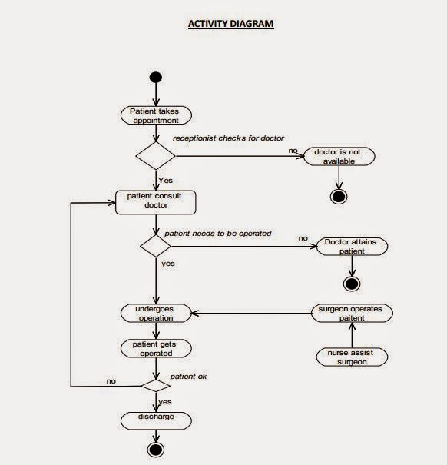

**SEQUENCE**

